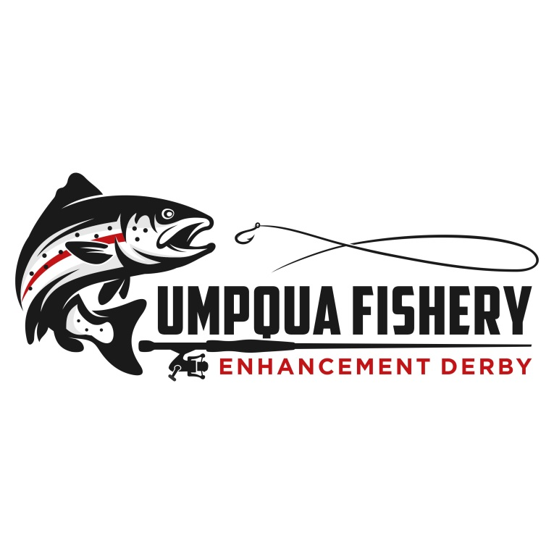
3000 NW Stewart Parkway, Suite 104
Roseburg OR 97471 | (541) 672-0757

PRESS RELEASE
April 1, 2022

CONTACT:
Tina Roy
Douglas Timber Operators
541-672-0757

2022 UMPQUA FISHERY ENHANCEMENT DERBY BANQUET
HAS BEEN RESCHEDULED
The annual Umpqua Fishery Enhancement Derby Banquet has been rescheduled for June 10th, 2022, at the Douglas County Fairgrounds (Douglas Hall). The event is sponsored by Douglas Timber Operators and the Umpqua Fishery Enhancement Committee.
The banquet is historically part of the annual four-day Umpqua Fishery Enhancement Derby. All the fishing Derby events took place in February except for the banquet due to low attendance expectations.
The schedule of events for the evening of June 10th are:
- 5:00 p.m. – Barbequed oyster bar sponsored by the Umpqua Fisherman’s Association, silent auction and social.
- 6:00 p.m. – Dinner
- 7:00 p.m. – The Program & Live Auction
There are some exciting auction items this year including a Willie Boat, fishing trips to Alaska and other locations, a four-wheeler, day trips and many other items that raise funds that all go toward projects benefitting the Umpqua Basin.
Tickets are available for purchase for $75 per person or $750 for a table of ten. You can register online: https://ufed.ejoinme.org/2022 , or by calling Tina Roy at (541) 672-0757. You can also email: tina@dougtimber.org
The Derby has contributed more than $1.8 million towards fishery enhancement, watershed restoration, and outdoor education projects in 28 years of the event. All the money raised from the event stays in Douglas County and provides matching funds for several projects annually, translating into an important investment that benefits everyone enjoying our valuable natural resources in Douglas County.

~~ END RELEASE ~~

